**Table of Contents**

1. Introduction …………………………………………………………………….

1.1 Project Background ………………………………………………………………….

1.2 Project Motivation …………………………………………………………………….

1.3 Project Goal ………………………………………………...……………………….

1.4 Project Requirements ………………………………………………………………….

1.4.1 Functional Requirements ………………………………………………………………

1.4.2 Performance and Quantitative Requirements ………………………………………….

1.4.3 Project Constraints …………………………………………………………………….

1.4.4 Optional Objectives …………………………………………………………………….

2. Technical Design ……………………………………………………………………….

2.1 System-level Overview ………………………………………………………………….

2.2 Module-level Descriptions ……………………………………………………………….

2.3 Assessment of Proposed Solution ………………………………………………………….

3. Testing and Verification …………………………………………………………………….

3.1 Validation and Acceptance Tests ………………………………………………………….

Conclusion …………………………………….…………….……………………………….

References ……………………………………………….………………………………….

Appendix A - Gantt Chart History …………………………………………………………….

Appendix B - Financial Summary …………………………………………………………….

Appendix C - Validation and Acceptance Tests from Project Proposal ……………………….

Appendix D - Project Prototype ……………………………………………………….

Appendix E - Scanning with the Prototype ………………………………………………….

Appendix F - Statistics on Precision of Scanner ………………………………………

Appendix G - Monitor Display of Scanned Object ………………………………………

Appendix H - 3D Graphics Display of Surfaces of Objects …………………………………

**1. Introduction** (author: Sen Yang)

This report summarizes the motivation behind the project: Implementation of a 3D Rotational Scanner. It outlines the requirements as well as the design implementations. Finally, testing and validation procedures and results are compiled and explained. This report concludes with a summary of improvements for future work, as well as addressing improvements to be made to compensate for failed tests.

A background on the 3D digital scanning industry will be provided in this section. This section will identify key benefits brought by digitally replicated models, obstacles that have stagnated 3D models to be widely available to consumers, and also outline requirements and validation metrics of implemented solutions tailored to addressing the specific obstacles identified.

**1.1 Project Background** (author: Sen Yang)

The demand for efficient, illustrative and comprehensible media is rapidly increasing, and is continuously replacing traffic for obsolete text-based media. 3D digital models are starting to replace 2D pictures from online catalogues to illustrations at work and home. Digital models provide accurate illustrations, improve productivity, and are vital inputs to design automations, simulations, websites, multimedia and most importantly, to the rapidly increasing amount of 3D printing applications in today’s electronics market [1]. As one example from a civil architectural structures modelling assessment reported, students used 410 hours to model using 2D tools where it took 248 hours using 3D modelling – “… [which resulted in] productivity improvement… of 21% to 61%.” [2]

In spite of the mass demand and productivity improvement 3D models promise, the main obstacle that prevents the majority of consumers from using 3D models is the difficulty in producing digital models from real-life objects. Correctly drawing a 3D object by hand using even the most advanced Computer Aided Design (CAD) tools can easily take 3 to 5 hours even for designers with experience [3]. A more feasible, efficient solution on the market are 3D scanners, which are devices that are capable of scanning physical objects using advanced optical devices and patterned lights. Most of the scanners, such as the MakerBotTM Digitizer, can easily cost more than $1,000 [4] and present economic barriers for small business groups and individual developers with limited budgets. On the other hand, low-end or Do-It-Yourself (DIY) scanners such as SardauscanTM [5] do not satisfy many of the functional needs sought out by the majority of identified users, as well as suffering from low quality, error prone scans. In addition, such DIY scanners also require the user to buy separate parts, assemble the scanner, and download the algorithms used onto the system assembled. This assembly process requires the user to have a technical background that most consumers do not possess.

The main gap to be addressed is the lack of consumer products segmented toward consumers with limited budget and technical background knowledge who require additional functionalities that current low-end scanners do not provide. The market is short of a cheap, efficient solution that can take a physical object and produce its digital 3D model. These models can be further utilized for automation, animation, object replication and other productivity needs.

**1.2 Project Motivation** (author: Sen Yang)

The main motivation for this project is the team members’ collective interests in implementing a complex electronic system that requires project planning, technical design, as well as learning and applying electronics, programming, computer graphics, and data processing knowledge into practice. In addition, successfully implementing this project provides members with a functional, fully customizable scanner which could otherwise cost thousands of dollars. The scanner can be used for 3D printing applications, and projects that use 3D models such as animation and games.

**1.3 Project Goal** (author: Sen Yang)

The end objective of this project is to implement a scanning system which observes a physical object of limited size and weight, and to digitally produce the corresponding 3D model files for monitor display.

**1.4 Project Requirements** (author: Sen Yang)

This subsection enumerates the list of project requirements, restrictions, and desirable attributes under objectives.

**1.4.1 Functional Requirements**

Table 1.4.1.1 (Table name)

|  |  |
| --- | --- |
| FR1 | The rotational system will use a stepper motor to expose all 360 degrees of the scanned object to an image taking device. The motor will rotate objects up to 350 grams [6] centered at the axis of rotation. This weight is limited by the torque rating of the selected motor, under a $50 budget [7]. |
| FR2 | The produced 3D digital replica must achieve at least a resolution of 10 pixels/cm2 from the surface of the scanned object. This is set by an optimal tradeoff point between the requirements of model definition and model data processing speed. |
| FR3 | The system will receive commands and send produced files to connected computer via an USB 2.0 connection, the mostly widely used protocol for PCs [8]. |
| FR4 | The C++ implementation must be compatible with a machine with the Windows 10 operating system. The program will not use more than 4GB of memory - the memory limit of the provided computation unit available to the group. |
| FR5 | The system will provide a preview of the scanned object on a connected display device, such as a monitor. |
| FR6 | The user will be able to rotate and scale the object on the display given. |

**1.4.2 Performance and Quantitative Requirements**

|  |  |
| --- | --- |
| FR7 | The apparatus will be as lightweight as possible. The scanner will be lighter than 2.0 kilograms, a weight estimate of the components employed. |
| FR8 | The digital replication process will have comparable scanning time to that of most low-end competition scanners [5]. It will take no longer than 20 minutes to scan an object. |
| FR9 | The apparatus will be as portable as possible, and will not exceed length, width, and height dimensions are of 50, 30, and 40 centimeters respectively. |
| FR10 | The system will observe and digitally replicate objects that can fit into a cylinder of 30 cm diameter and height. This is restricted by the strength and quantity of lasers and cameras employed. |

**1.4.3 Project Constraints**

|  |  |
| --- | --- |
| PC1 | Hardware input power supply must not exceed 110 volts, at 60 Hertz if using AC, which is the power supply standards for North America [9]. |
| PC2 | The project goal must be met no later than March 30, 2016, as outlined by project syllabus [10]. |
| PC3 | Materials and parts cost must not exceed $150 for prototype, and $50 each for production estimated for 1,000 units [5]; these costs excludes labor and overhead costs. |

**1.4.4 Optional Objectives**

|  |  |
| --- | --- |
| OO1 | The digital replication process should be as systematic as possible; the user should take no more than 5 minute to set up the apparatus for the digital replication process. |

**2. Final Design** (author: Jing Guan)

This section presents the high level overview of our final design. Please see Appendix D for images of the final project.

**2.1 System-Level Overview** (author: Jing Guan)

This section gives a high-level overview of the proposed solution as well as a system block diagram that illustrates the process flow of the project. The selected alternative builds on top of existing solutions available on the market, such as the SardauscanTM [5], to make 3-D scanning affordable to the general public while improving functionality.

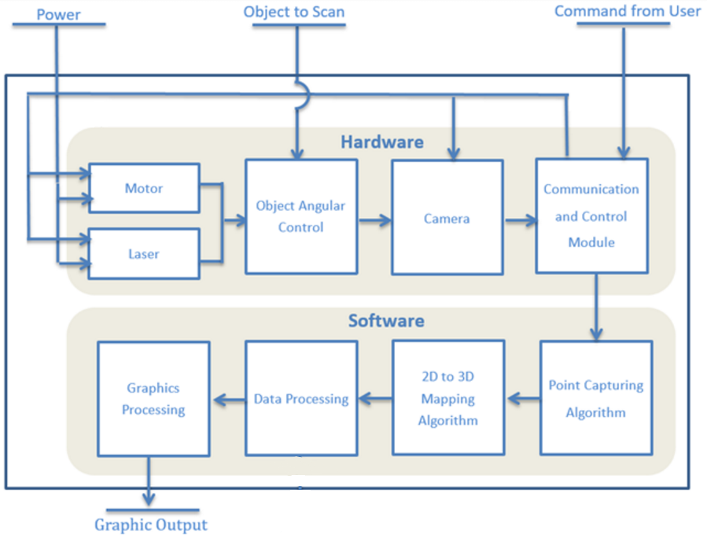

Figure 2.2System Block Diagram of Laser Line Scanner

As Figure 2.2 illustrate, a motor rotates a plate on which an object is placed while a laser shines a continuous line on the object for the cameras to capture. The image data is then transmitted to a computer. The collection of 2D images is computed to extract 2D points, which are mapped to 3D points in space. The 3D data is further processed to certain formats suitable for 3D printing and graphical display. Please refer to Appendix D for images of the design setup.

**2.2 Module-Level Descriptions** (author: Jing Guan)

This section provides detailed descriptions of the modules outlined in the system level diagram above.

**2.2.1 Hardware**

|  |
| --- |
| Motor |
| *Input*: Power, and control signal from communication and control module |
| *Output*: Rotational movement of the original object |
| *Requirement:*  · The motor’s input power will be 110 volts, 60 Hertz (AC)  · The angles of rotation will be consistent |
| *Function*: The motor should be able to rotate and stop at fixed intervals until a 360 degree rotation is achieved |

|  |
| --- |
| Laser |
| *Input*: Power, and control signal from communication and control module |
| *Output*: Vertical beam of light |
| *Requirement:*  · The laser will use a DC supply of 5 volts, the standard DC output from Arduino board |
| *Function*: Shines a beam of light towards the object to scan at an angle visible to the webcam |

|  |
| --- |
| Object Angular Control |
| *Input*: Uses the output of motor, laser and object to be scanned |
| *Output*: An angle specific, visible and deformed line from the laser on the object to be scanned |
| *Function*: Composed of the plate, motor and laser, this system provides an angular control of the object to scan |

|  |
| --- |
| Camera |
| *Input*: Power, and the scene set up by the scene generator |
| *Output*: Image file of the object |
| *Requirement:*  The camera has a resolution of at least 1.3 Megapixel. This is the resolution of common, inexpensive webcams currently available that satisfy the resolution requirement |
| *Function*: The camera takes pictures of the object and sends image files to the communication and control module for further processing |

|  |
| --- |
| Communication and Control Module |
| *Input*: User commands, and image data captured by the camera |
| *Output*: Control signals to hardware units, and image data into the computer’s memory |
| *Requirement:*  · The system interconnection and communication module is done using USB 2.0 |
| *Function*: The module starts and stops hardware modules according user commands. It transmits the data of captured pictures from camera to computer for processing |

**2.2.2 Software**

|  |
| --- |
| Point Capturing Algorithm |
| *Input*: Data of captured pictures |
| *Output*: Computed two dimensional position of laser beam represented by its value in a 2D Cartesian coordinate |
| *Requirement:*  · The algorithm should be able to eliminate the noise |
| *Function*: The module scans the captured images for pixels that are laser points, and records these point coordinates |

|  |
| --- |
| 2D to 3D Point Transformation |
| *Input*: Coordinates of 2D points from point capturing algorithm |
| *Output:* Coordinates of laser beam in 3D Cartesian coordinate |
| *Function*: The module computes a corresponding 3D point from each of the given 2D point from input file using trigonometric mappings based on the angle and position of the camera and the laser |

|  |
| --- |
| Data Processing |
| *Input*: Collection of all 3D points computed from the 2D to 3D transformation module |
| *Output*: .OBJ file and .STL file that represents the scanned object |
| *Requirement:*  · The mesh object created must be free of floating data points  · The mesh object must be written using both .OBJ file and .STL file format |
| *Function*: The module will transform the 3D points into surfaces by meshing the 3D points. The module will also prepare the mesh so that it will be acceptable for 3D printers and graphic tools |

|  |
| --- |
| Graphics Processing |
| *Input*: An .OBJ file describing the positions of the polygons that makes up an object’s surface |
| *Output*: 3D data stream required for displaying such object on a display monitor |
| *Requirement:*  · Written code must be compatible for OpenGL processor  · The user will be able to rotate and scale the object in real time |
| *Function*: The module will process 3D model description data and display them on a monitor, while allowing the user to rotate and scale the object displayed in real-time |

**2.3 Assessment of Proposed Solution** (author: Jing Guan)

This section will evaluate the benefits and drawbacks of the proposed solution, as well as stating trade-offs made during decision.

The proposed solution, a 3-D rotational scanner using lasers and sensors, offers advantages of scanning time, simplicity, and cost.

1. Scanning time: Based on estimation, scanning and data collection takes no more than six minutes, and the subsequent data processing requires at most two minutes. Therefore, the whole process takes no more eight minutes. In comparison, the time needed for handheld device will depend on desired accuracy and object size, and can be “unbearably slow” according to an online review [11].
2. Simplicity: The proposed solution is simple for the user to use, as the user just needs to place the object on the plate and press “start”. Because the scanning process is automated and the set-up procedure is straightforward, a user with little relevant technology background can easily operate the scanner. In comparison, the handheld device requires the user to manually scan through the object holding the device. Also, many products require a complex and time-consuming set-up procedure before the first scan.
3. Cost: A web-camera, a Servo motor and a PVC plastic plate can achieve the required precision as well as the strength to hold an object up to 350 grams. Therefore, the estimated cost will not exceed $50. In comparison, current products on the market takes from $500 up to over $10,000.

The proposed solution has unavoidable disadvantages in capabilities of scanning large-scale, heavy objects. This is mainly restricted by the motor and size of the completed system. Also, it’s slightly heavier and larger compared with the handheld device.

Since the goal is to develop an easy-to-use, relatively fast and affordable 3D scanning system for the consumer market, the solution trades the capability to scan large items for low cost and ease of use.

**3. Testing and Verification** (author: Emily Miao)

This section presents the methods of testing and verifying the projects meets the various functional requirements. It also presents the final results of each functional requirement test, its compliance measure, and any additional comments on each test.

**3.1 Validation and Acceptance Tests** (author: Emily Miao)

Table 3.1 below summarizes the various specifications used to validate and test the functional requirements from section 1.4.1 and 1.4.2. It also summarizes the test results, as well as whether or not the results comply with the target specifications and any additional notes.

Table 3.1 Validation Metrics

|  |  |  |  |  |
| --- | --- | --- | --- | --- |
| **Requirement**  **(# & title)** | **Target**  **specification** | **Final**  **Result** | **Compliance(Pass/Fail)** | **Comments and Documentation** |
| FR1 - Motor specifications | The motor is able to complete 360 degrees rotation while supporting a mug weighing 350 grams | Able to scan a mug weighing 350 grams | Pass | See Appendix E |
| FR2 - Scanning precision | The generated point cloud have at least 10 points for every square centimeter of the object’s surface area scanned. | 286 dot per squared centimeter | Pass | See Appendix F for statistical results |
| FR3 - Communication device compatibility | The system is able to scan an object, and send data to the computation device through USB 2.0 | System is connected through USB | Pass | Appendix E |
| FR4 - Computer system compatibility | The software runs on a Windows 10 computer with at least 4GB of memory | Software runs on a Windows 10 computer with 4GB memory | Pass | Appendix E |
| FR5 - Preview digital replica on a monitor display | The generated file is able to be displayed on a monitor | Able to display the 3D point cloud of objects | Pass | All scanned objects can be displayed as 3D point clouds, see Appendix G. Simple objects such as cubes can be displayed as surfaces, see Appendix H. |
| FR6 - Rotation and scaling of digital display | The object displayed on the monitor is able to zoom in and out based on user input | Able to rotate and scale the 3D point cloud | Pass | See Appendix G. |
| FR7 - Apparatus weight | When weighted on a scale, the system should not be more than 2.0 kilograms | Weight of 1.3kg | Pass |  |
| FR8 - Scanning time | Scanning time should be less than 20 minutes | 12 minutes 30 seconds | Pass | Time to scan objects is independent of object size |
| FR9 - Apparatus size | Apparatus length, width, and height dimensions are no larger than 50, 30, and 40 centimeters | Width of 49cm, height of 35.8cm, and depth of 28.8cm | Pass |  |
| FR10 - Size of object being scanned | The system is able to digitally replicate object that can fit into cylinder with diameter of 30 cm and height of 30 cm | Maximum diameter is 22.5cm, height is 17.5cm | Fail | The maximum dimensions we can scan is 20% smaller in diameter 42% shorter than the specifications. This is limited by the camera’s field of view and the size of the apparatus. For more information, see Appendix E |

**Conclusion** (author: Emily Miao)

Although 3D modelling with CAD tools is productive in the workplace, it is also difficult and time consuming. 3D scanners currently in the consumer market are too expensive for small businesses, while affordable scanners may not offer all the functionalities consumers are looking for. The team solves this problem by building on top of existing 3D scanning technology to produce a 3D scanning system that is efficient and affordable without sacrificing functionality. By using a 3D rotational scanner with a laser and camera, the team is able to produce a system that captures the 2D images of the object with hardware components, and processes the information captured to produce the 3D digital replica with software. Overall, this system achieves the goals of providing an affordable and efficient 3D scanner that produces a 3D printer compatible file.

The testing and verification procedure extensively tests the projects from many aspects to prove its functionality. The tests not only tests the limitations on hardware implementation, but also software compatibility. The final design has also been tested extensively by scanning multiple objects, and visually checking that the scanned object represents the original.

The final design meets all functional requirements of the project with the exception of the maximum size of the object that can be scanned. The size of the scanned object is dependent on the camera and distance from the camera to the rotational plate. Although the team can use a better camera, or move the camera further away, this will result in a more expensive or larger prototype. With these in mind, the team has decided to forgo the maximum size of the object that can be scanned to achieve a more portable and affordable prototype.

Many aspects of this project can be further improved. The integration between the 3D point cloud and 3D graphical display is not yet integrated due to complication in mapping objects with uneven surfaces. Furthermore, the OBJ and STL file generation for 3D printing automation is still in progress [12][13]. Although the project can be further expanded and improved, the team has achieved the functional requirement of scanning a 3D object and displaying the object on a monitor.

**References**

[1] Mark Driscoll, “Kickstart your manufacturing productivity with 3D design tools”, 3DxBlog, [Online] 2013, URL: http://blog.3dconnexion.com/blog/bid/266767/Kickstart-Your-Manufacturing-Productivity-with-3D-Design-Tools Accessed: 2015 September

[2] Dr. Rafael Sacks, “A Qualitative and Quantitative Assessment of the Impact of 3D Modelling of Building Structures on Engineering Productivity” Israel Institute of Technology, Espoo, Finland, 2005

[3] Blake Senftner, “How long does it take an experienced 3D artist to model a basic 3D humanoid model from scratch?”,Quora, [Online] 2014, URL: https://www.quora.com/How-long-does-it-take-an-experienced-3D-artist-to-model-a-basic-3D-humanoid-model-from-scratch Accessed: 2015 September

[4] “MakerBot Digitizer - 3D Scanner”, Dell, [Online], URL: http://accessories.us.dell.com/sna/productdetail.aspx?c=ca&l=en&s=&cs=cadhs1&sku=A7516720&dgc=ST&cid=31209&lid=5353066&acd=1230881384347400&ven1=sBvAgmohk&ven2 Accessed: 2015 September

[5] “Sardauscan $30 DIY 3D Scanner”, 3D Printing .com, [Online] 2015, URL: http://3dprinting.com/how-to/sardauscan-30-usd-diy-3d-scanner-3d-print/ Accessed 2015 September

[6] “How much does a coffee mug weigh in grams”, ChaCha, [Online] 2011, URL:http://www.chacha.com/question/how-much-does-a-coffee-mug-weigh-in-grams Accessed: 2015 September

[7] “Results for Servo Motors”, Amazon Canada, [Online] 2015, URL: https://www.amazon.ca/s/ref=nb_sb_noss_1?url=search-alias%3Daps&field-keywords=servo+motor Accessed: 2015 October

[8] “The Universal Serial Bus: What it is and how it works”, G. Knagge, [Online] 2015, URL:

http://www.geoffknagge.com/uni/elec101/essay.shtml Accessed: 2015 September

[9] “Country Household Voltages and Plug Styles”, PowerStream, [Online] 2015, URL: http://www.powerstream.com/cv.htm Accessed: 2015 September

[10] “ECE496 Course Milestones and Deliverables Summary”, University of Toronto, [Online] 2015, URL: https://internal.ece.toronto.edu/ece496.1415/pages/students/schedule-deadlines.html Accessed: 2015 September

[11] Digital Harbor Foundation, “[3D Scanners: A Quick Review](http://www.digitalharbor.org/2014/10/10/3d-scanners-quick-review/)”, 3D Printing for Educators, [Online] 2014, URL:

http://www.digitalharbor.org/2014/10/10/3d-scanners-quick-review/ Accessed: 2015 October

[12] “Object Files”, Paul Bourke, [Online], 2015, URL:

http://paulbourke.net/dataformats/obj/ Accessed: 2015 October

[13] “What is an STL File?”, 3D Systems. [Online] 2015, URL:

http://www.3dsystems.com/quickparts/learning-center/what-is-stl-file Accessed: 2015 October

**Appendix A - Gantt Chart History** (author: Emily Miao)

A few notes on the Gantt Chart:

* The granularity of time unit is weekly as tasks are divided to shorter items across the year to allow work to be done in parallel. This also gives flexibility for team members to juggle between the project and other academic commitments.
* Project cells are shaded with the pattern associated with the team member responsible for that particular item, as seen in the legend.
* Milestones are placed in the Gantt chart to help the group keep track of actual and expected progress and are identified by bold font, indicating the end of a specific group of functional similar tasks.
* For all of the tasks identified, the group expects the coordinator to be fully in charge of the task, while all other members are expected to assist when requested.

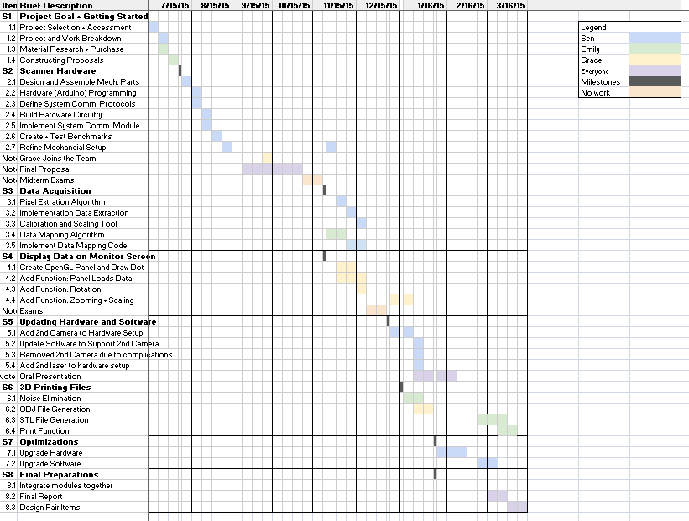

Figure A.1 Current Gantt Chart

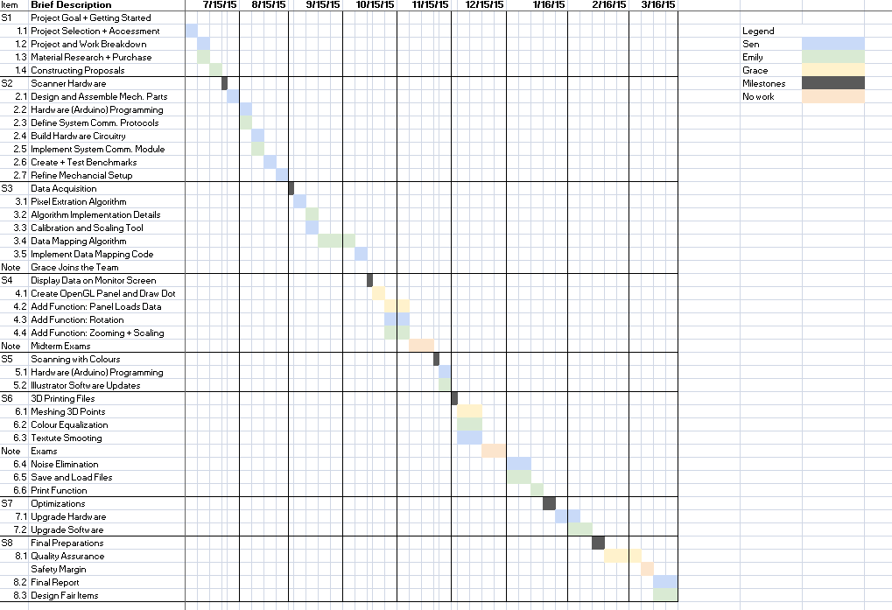

Figure A.2 January 2016 Gantt Chart

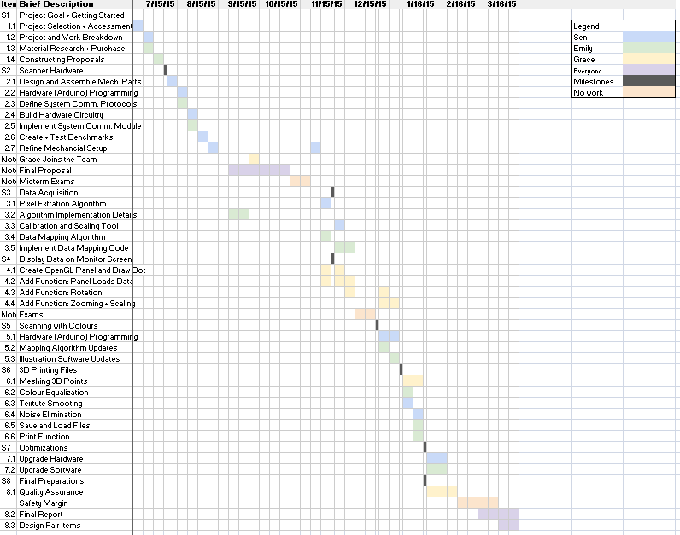

Figure A.3 December 2015 Gantt Chart

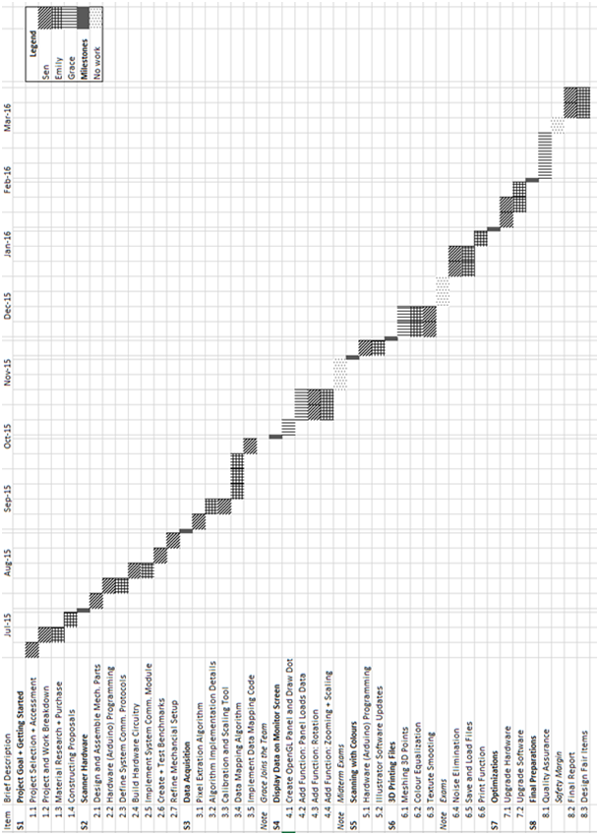

Figure A.4 Project Proposal Gantt Chart

**Appendix B - Financial Summary** (author: Sen Yang)

The following chart records past spending and project future spending for this project. Items listed below include consumable material, capital equipment and labour. Human resource costs are identified by the required roles to better illustrate the tasks the project entails.

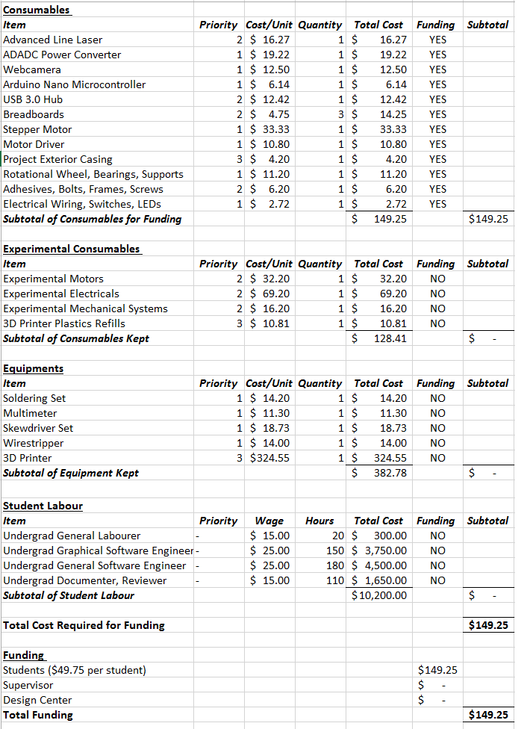

Figure B.1 Financial Plan Forecast

**Appendix C - Validation and Acceptance Tests from Project Proposal** (author: Emily Miao)

Table C.1 Validation Metrics

|  |  |
| --- | --- |
| **Functional Requirements Tested** | **Method of Testing** |
| Produce digital model in .OBJ and .STL format | The generated files can be imported and opened with various CAD software such as 3DSlash [14] |
| The motor is able to rotate an object of 350 grams in 360 degrees. | The motor is able to complete 360 degrees rotation while supporting a non-transparent cup filled with food, such as rice, to achieve weight of 350 grams |
| The surface of the digital replica achieves a precision of 10 points per square centimeter | The generated .OBJ files have at least 10 points for every square centimeter of the object’s surface area scanned. |
| Transmit information to computation device through USB 2.0 | The system is able to scan an object, and send data to the computation device through USB 2.0 |
| The compiled software C++ code is compatible with Windows 10, and can operate on a machine with 4GB of memory | The software runs on a Windows 10 computer with at least 4GB of memory, and is able to generate .OBJ and .STL files |
| Preview digital replica on a display | The generated file is able to be imported and displayed using CAD programs |
| Rotate and scale displayed digital replica based on user input | The object displayed in the CAD program is able to zoom in and out based on keyboard controls |
| Apparatus is no heavier than 2.0 kilograms | When weighted on a scale, the system should not be more than 2.0 kilograms |
| Digital replication process takes less than 20 minutes | 10 objects of different shapes and sizes are digitally replicated and the corresponding scanning time is recorded. All the recorded scanning time should be less than 20 minutes |
| Apparatus dimensions are no larger than 35.56 x 25.4 x 12.7 centimeters | The completed system should be able to fit inside a box of dimensions 35.56 x 25.4 x 12.7 centimeters |
| The system is able to digitally replicate object that can fit into cylinder with radius of 20 cm and height of 20 cm | A hollow cylinder 20 centimeters in radius is created using a 3D printer. The system should be able to digitally replicate the printed cylinder |

The validation process will consist of digitally replicating multiple physical objects, and be able to produce a digital replica of the object with 3D printing technology. At least 10 objects of various shapes, sizes, and weight will be digitally replicated using the system. One object will be a cup filled with food to achieve a total weight of 350 grams, and another will be a 3D printed cylinder with a radius and height of 20 centimeters. This is to test the maximum weight and physical dimensions the system should support.

After scanning each object, the generated files will be imported and opened with a CAD program so the 3D image of the scanned object is displayed on a monitor. Further testing will consist of viewing the object from different perspectives by zooming into the object and rotating the object using the CAD program. The validation methods to test the requirements are outlined in table 1.5 above.

**Appendix D - Project Prototype** (author: Emily Miao)

The exterior and interior view of the project’s final prototype as well as some features of this prototype is attached below.

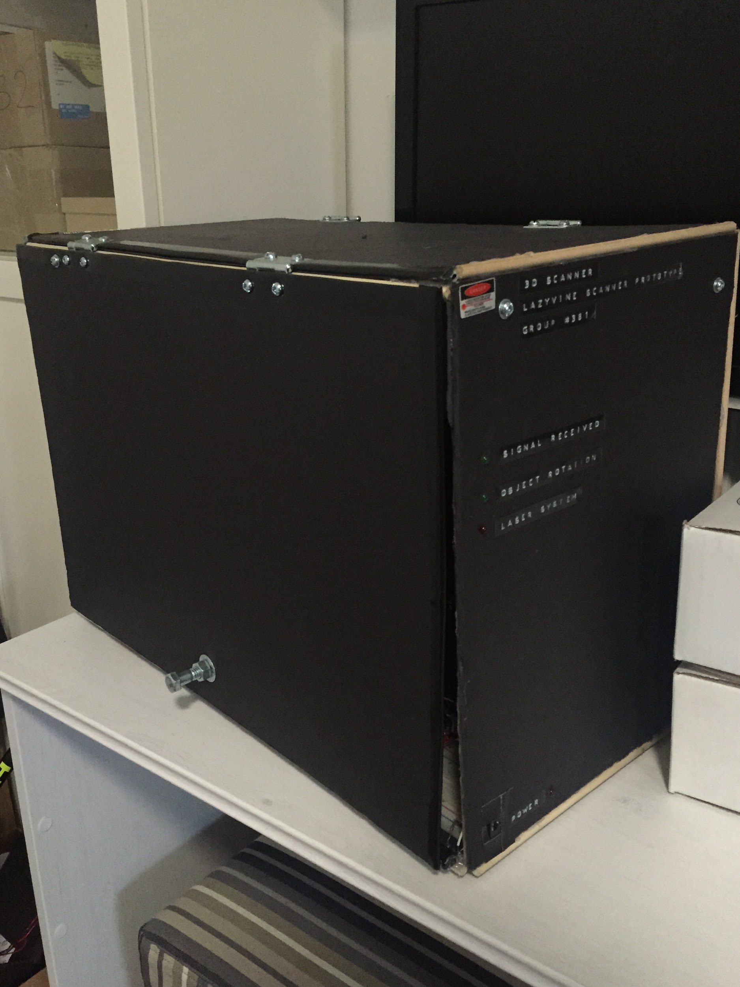

Figure D.1 Exterior View of Project Final Prototype

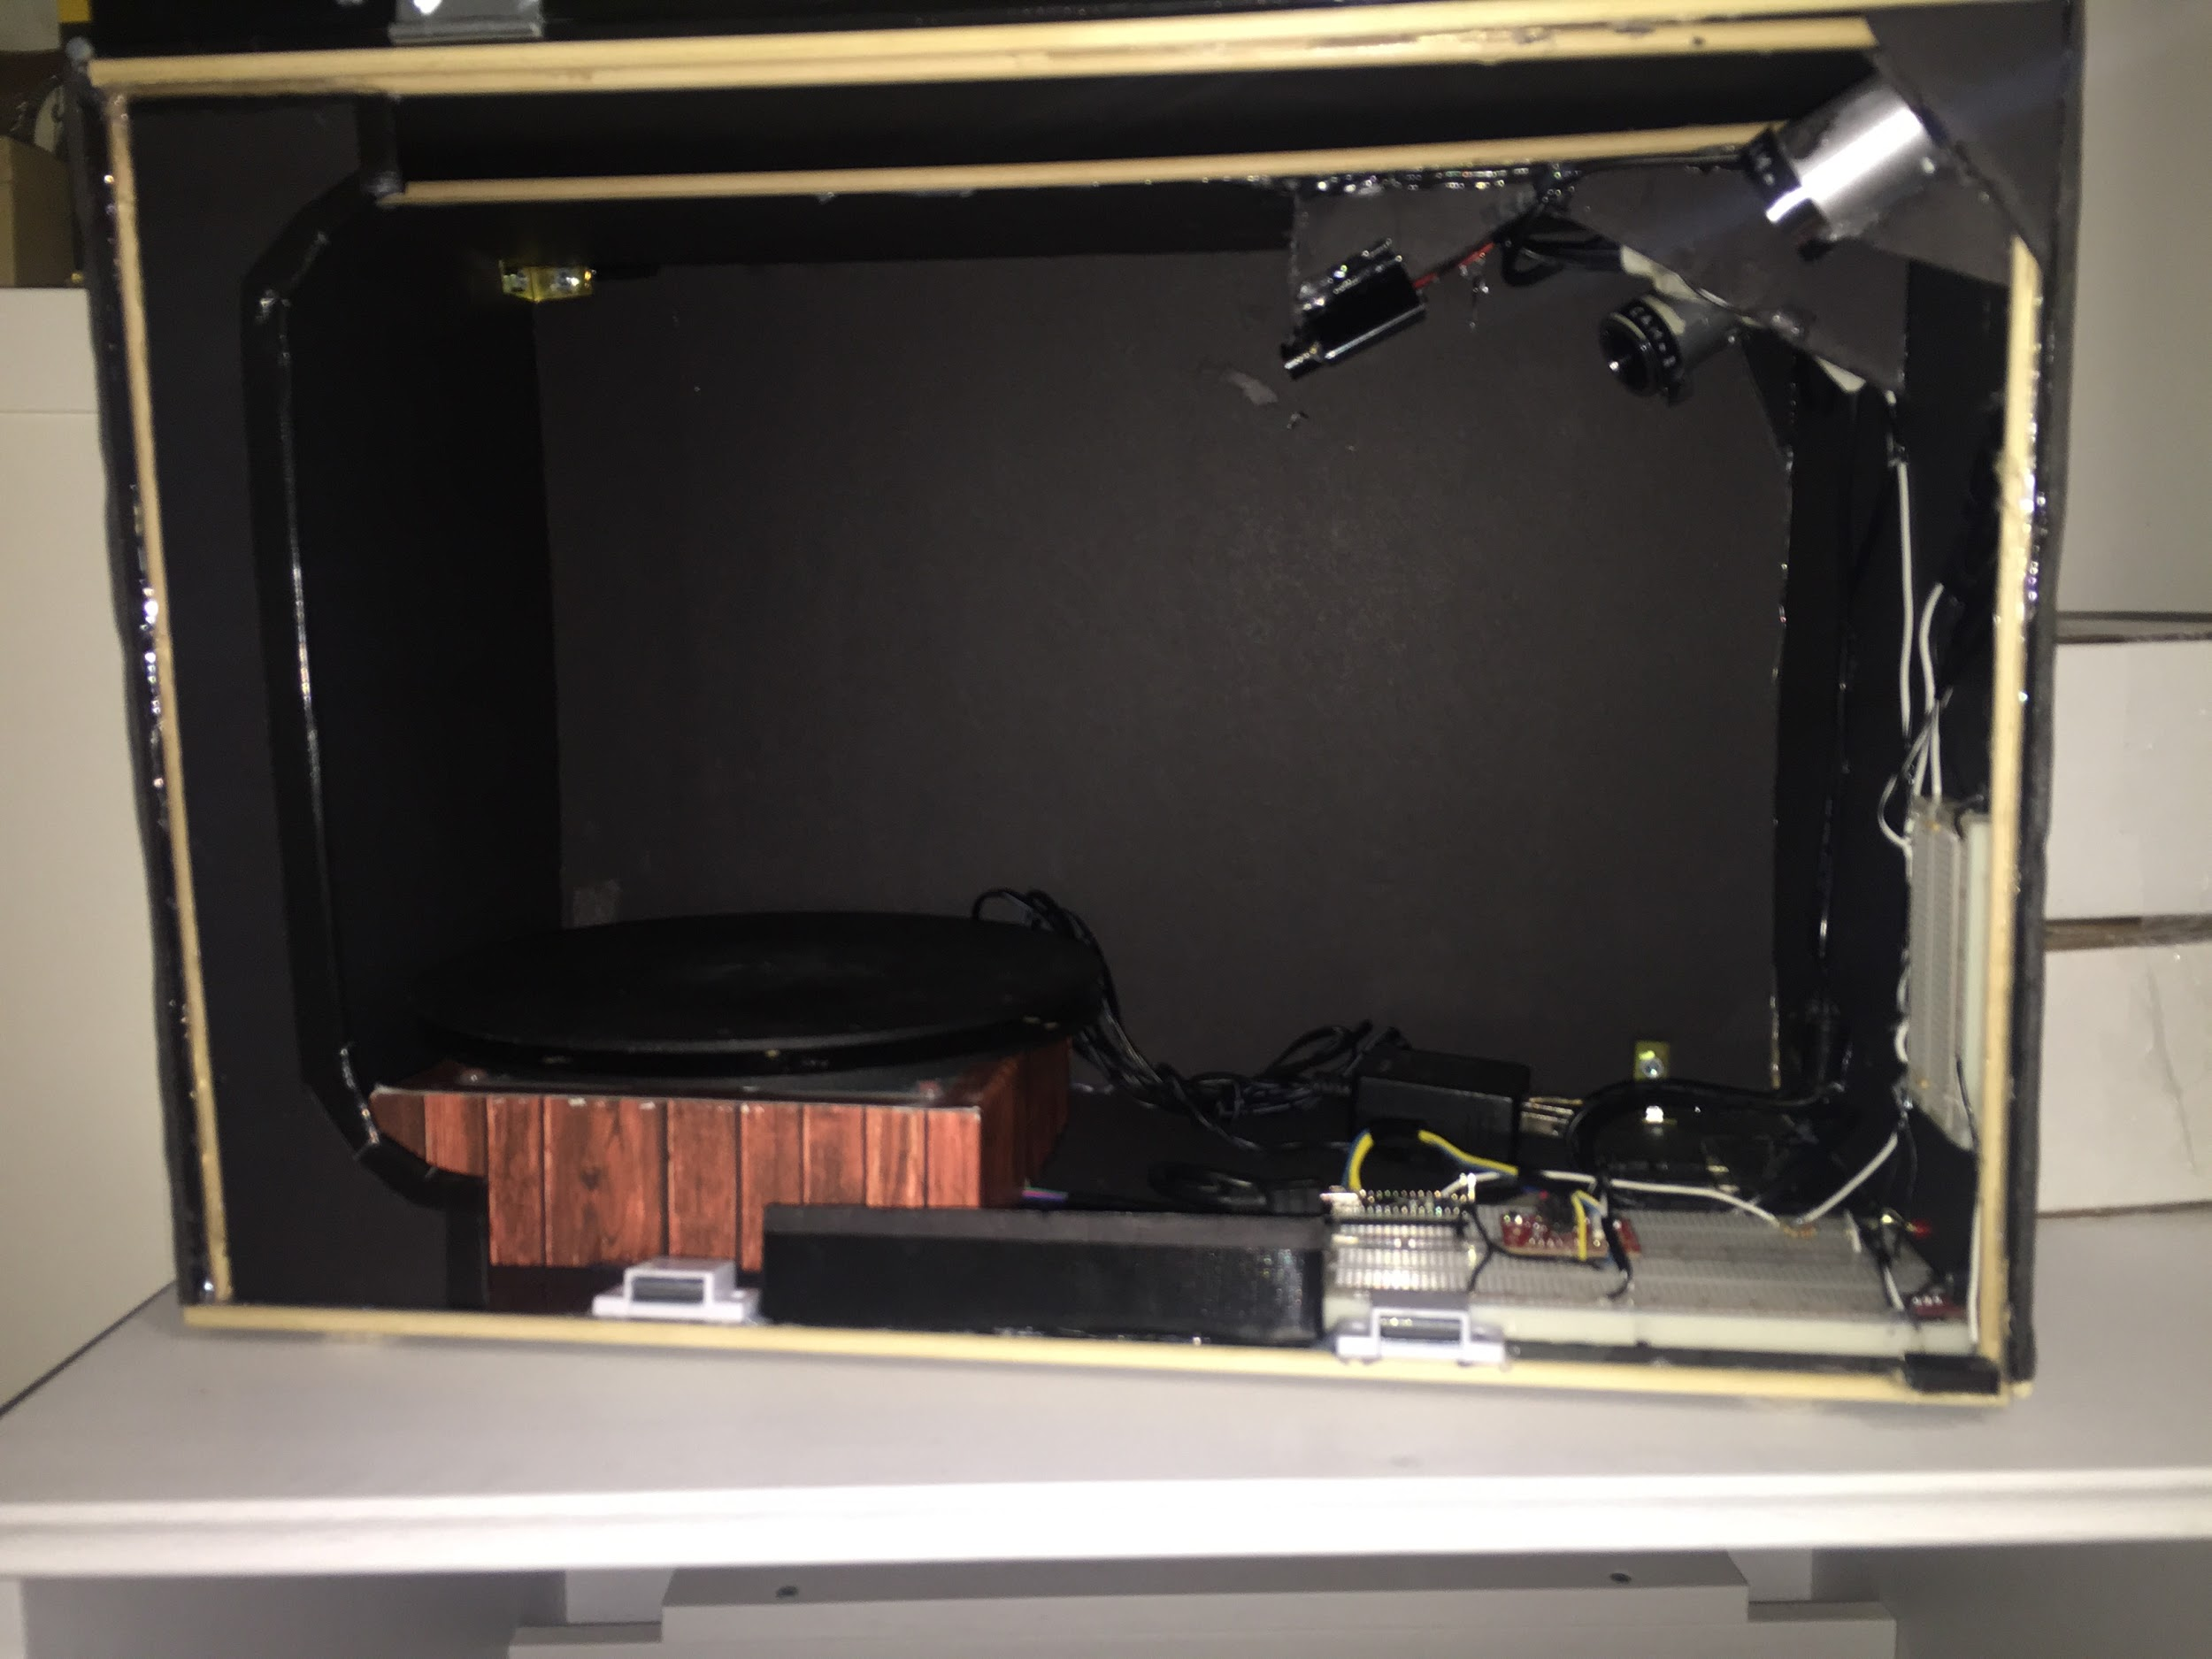

Figure D.2 Interior View of Project Final Prototype

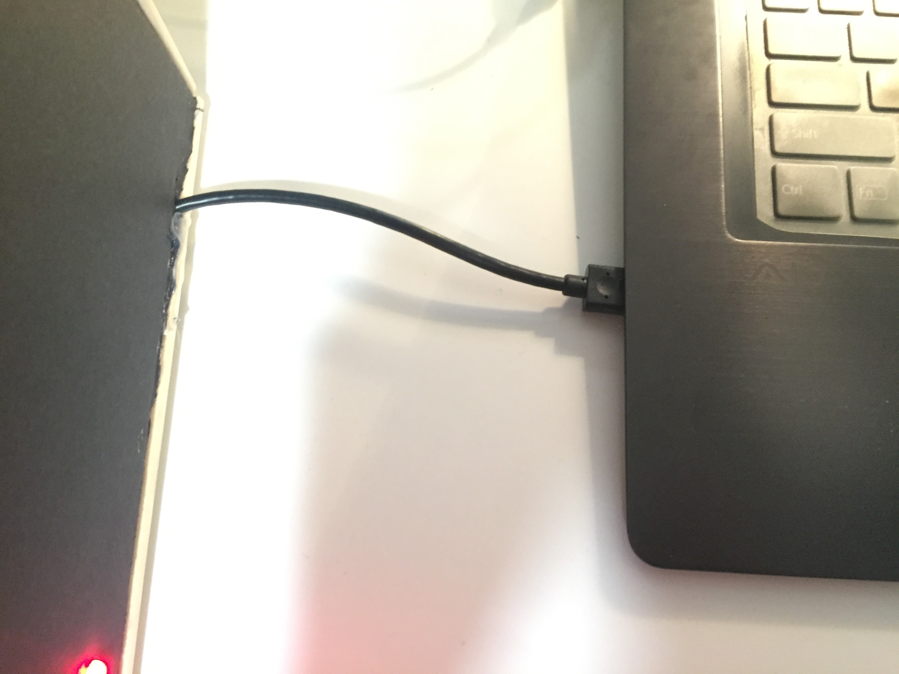

Figure D.3 USB Connection from Scanner to Laptop Computer

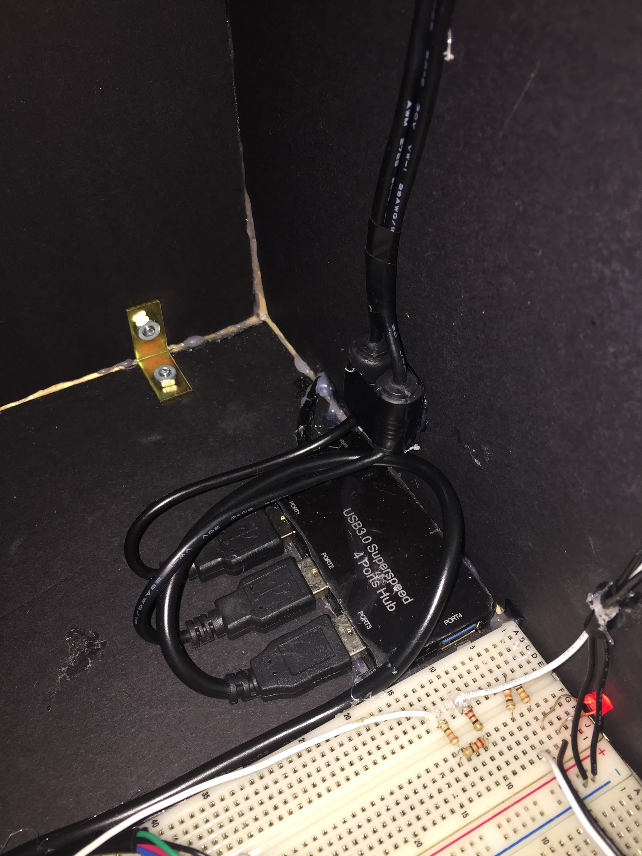

Figure D.4 Wire Organization using USB Hub

**Appendix E - Scanning with the Prototype** (author: Emily Miao)

Pictures of the scanner in use is attached below.

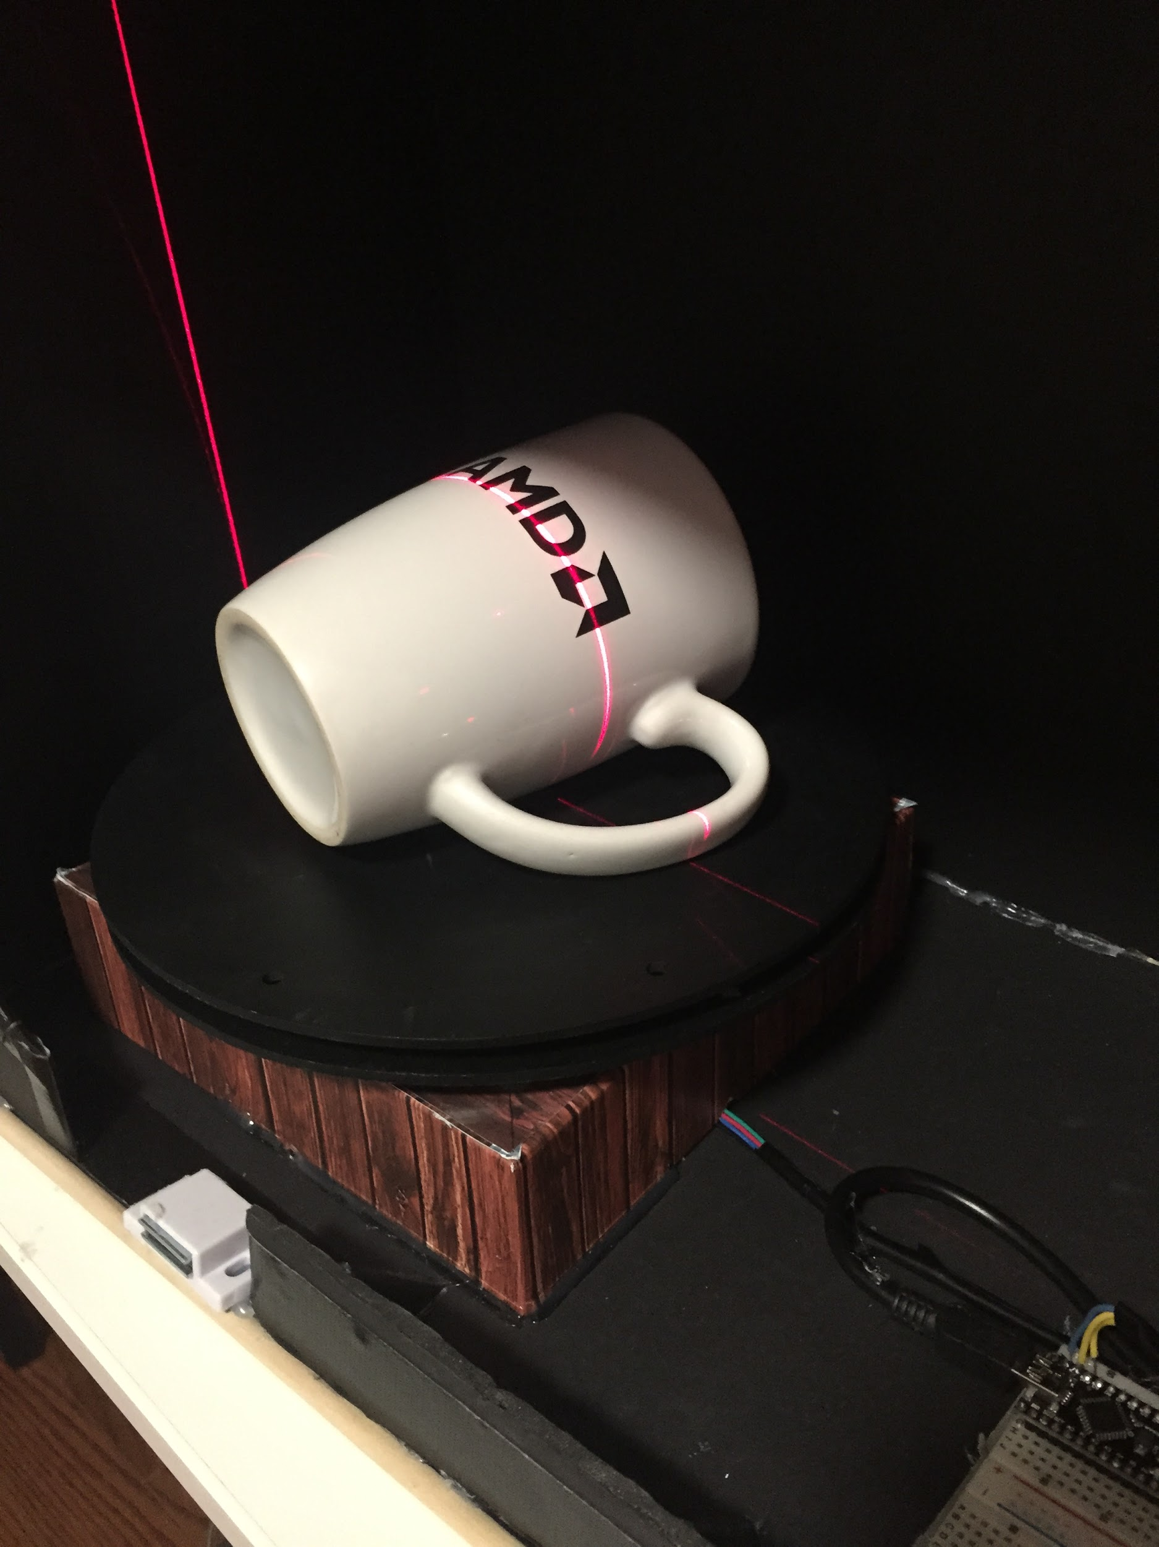

Figure E.1 Scanning a Mug

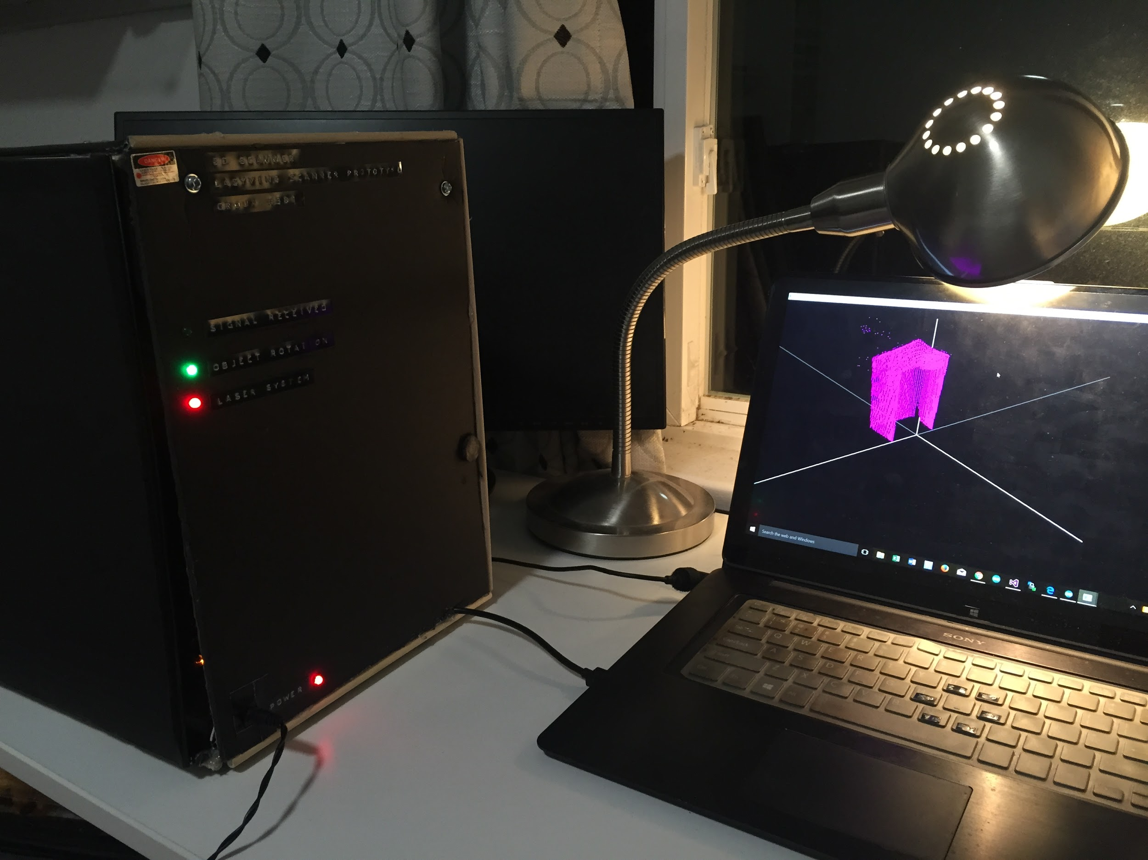

Figure E.2 Scanning in Progress. Computer Computing Data Received from Scanner through USB 2.0 Connection

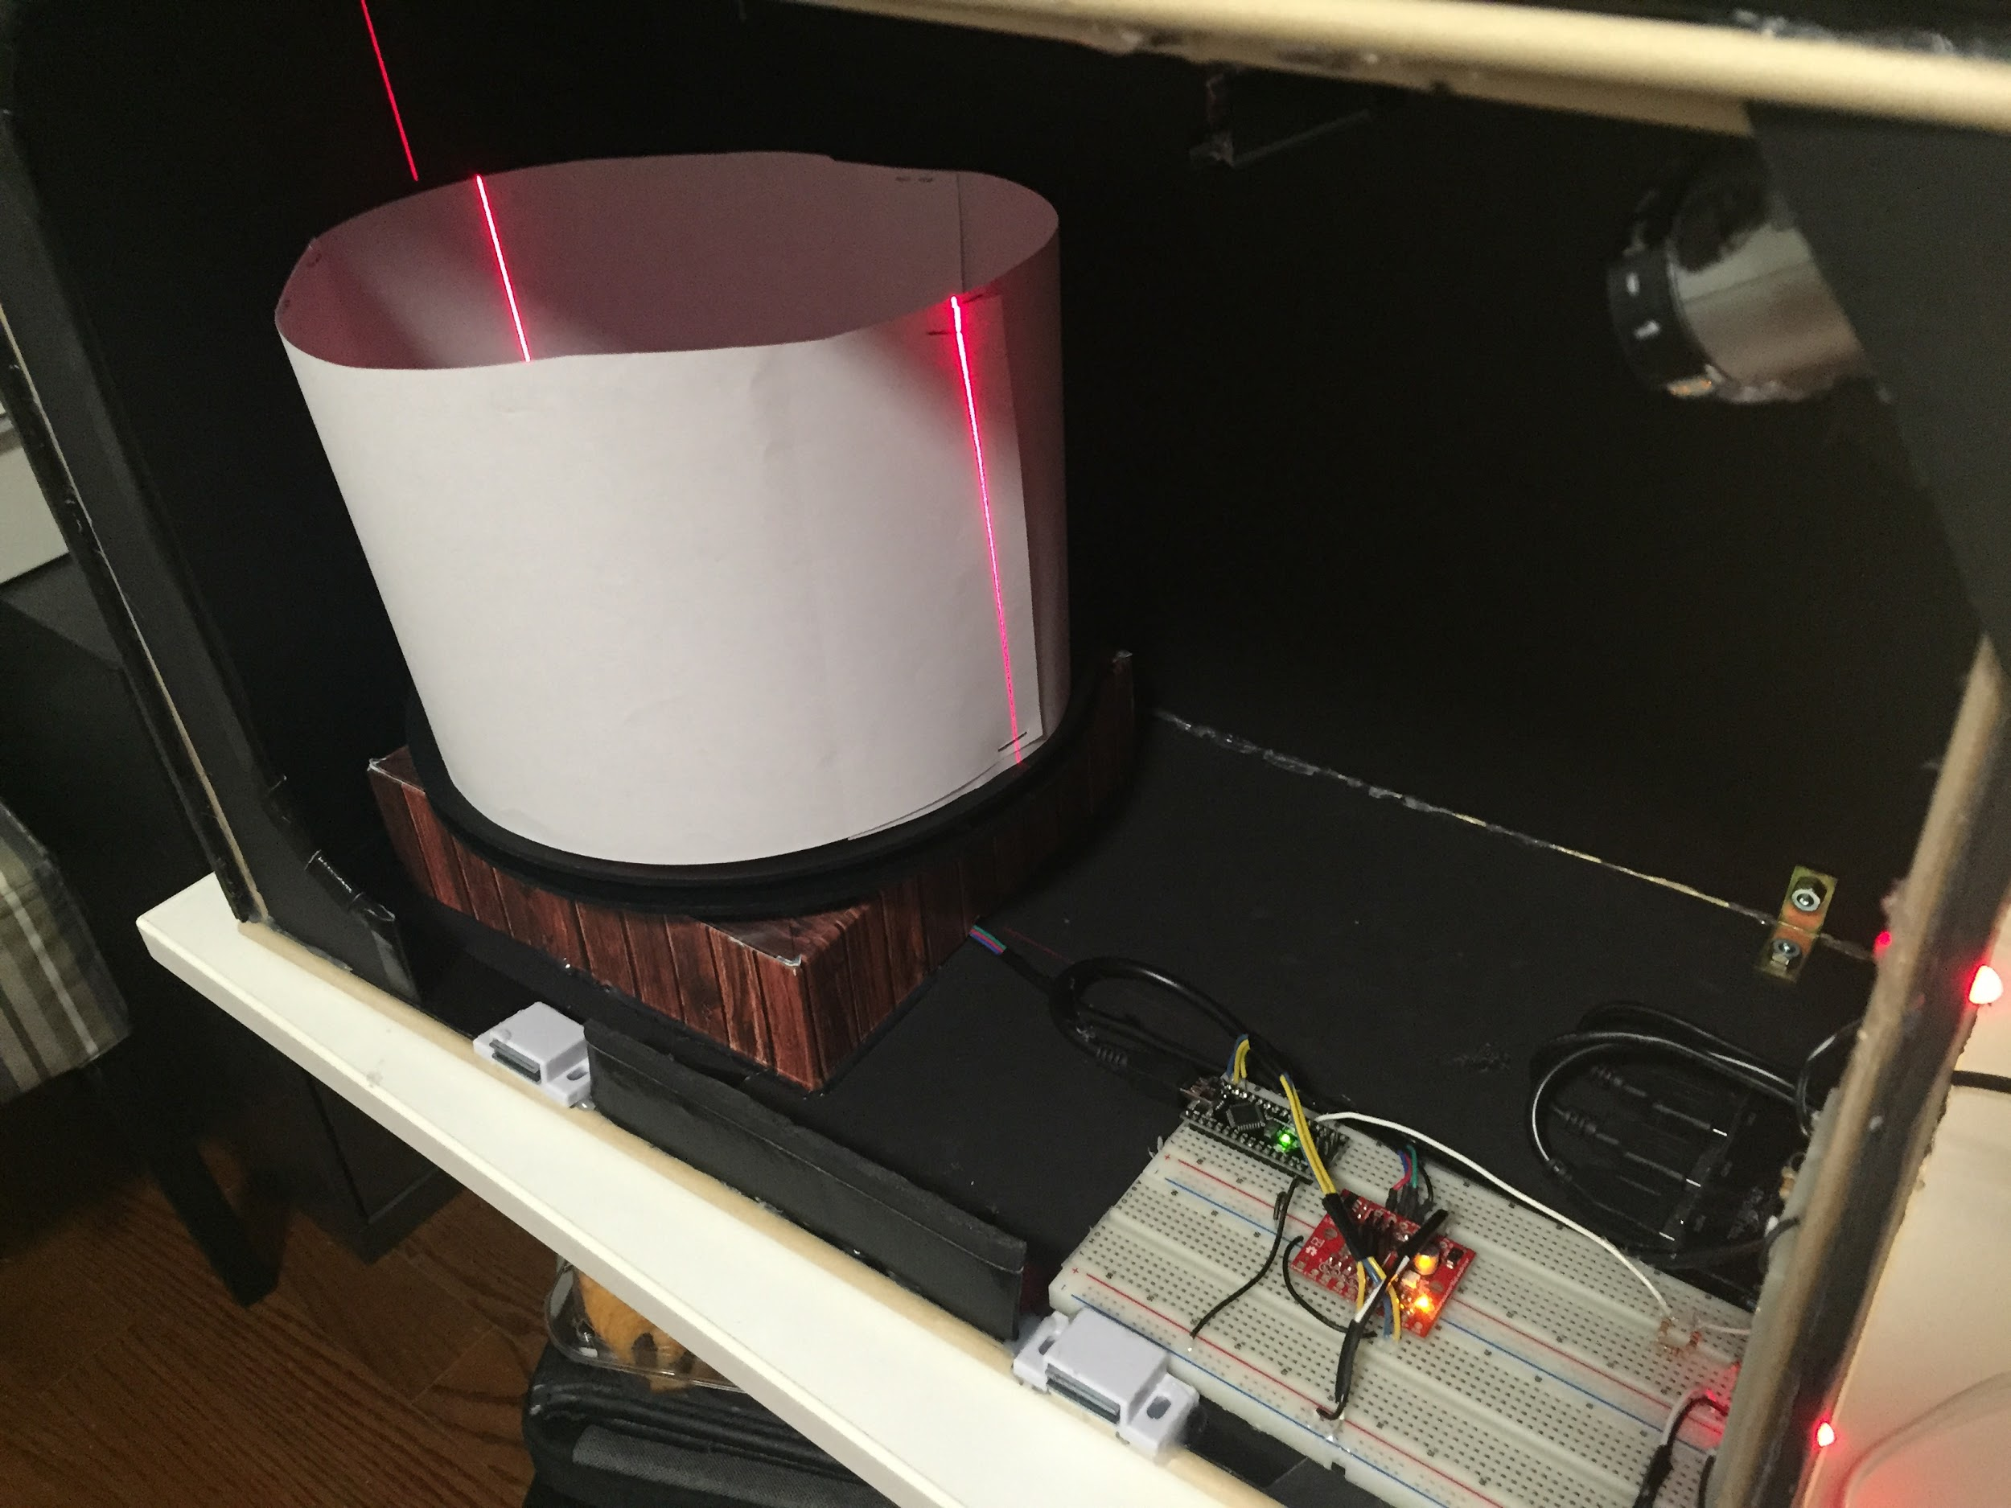

Figure E.3 Scanning a Cylinder of Radius 22.5 cm and Height 17.5 cm

**Appendix F - Statistics on Precision of Scanner** (author: Emily Miao)

The precision of the scan is measured by scanning a rectangular box of known dimensions and obtaining the number of dots used to form the object. Using these two statistics, the dots per squared centimeter can be calculated. The statistics and calculations are below. Since the bottom surface of the box is not scanned, we will not be using that as a part of the surface area calculations.

Dots formed: 116257

Dimension of box: 6.3 width x 8.5 length x 11.9 height (units in centimeters)

Surface area of box scanned = top surface of box + 4 sides of box = 405.79 cm2

Precision of scan = dots per cm = dots formed / surface area of box scanned = 286

**Appendix G - Monitor Display of Scanned Object** (author: Emily Miao)

This sections includes screenshots of the scanned object displayed as 3D point clouds on the monitor display.

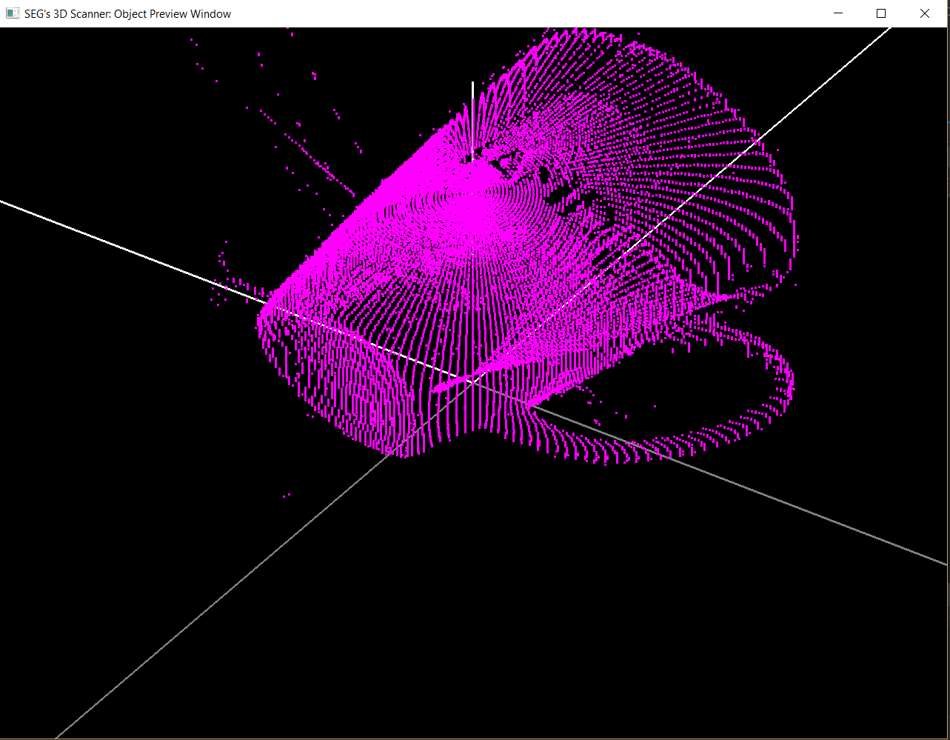

Figure G.1 Image of a Scanned Mug

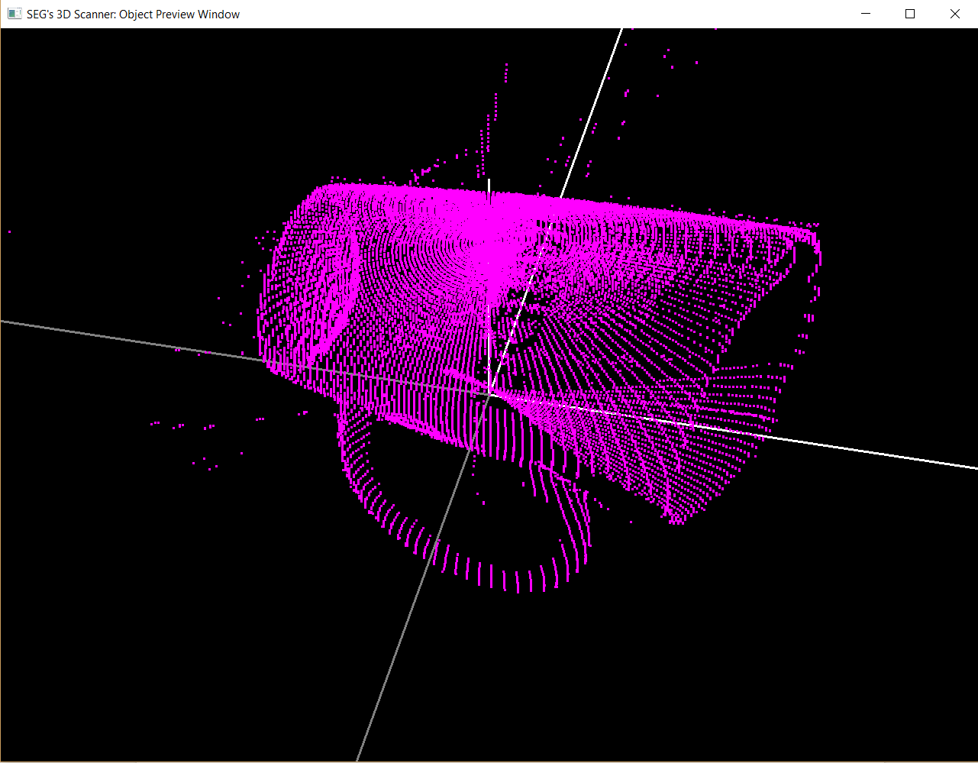

Figure G.2 Image of a Scanned Mug Rotated

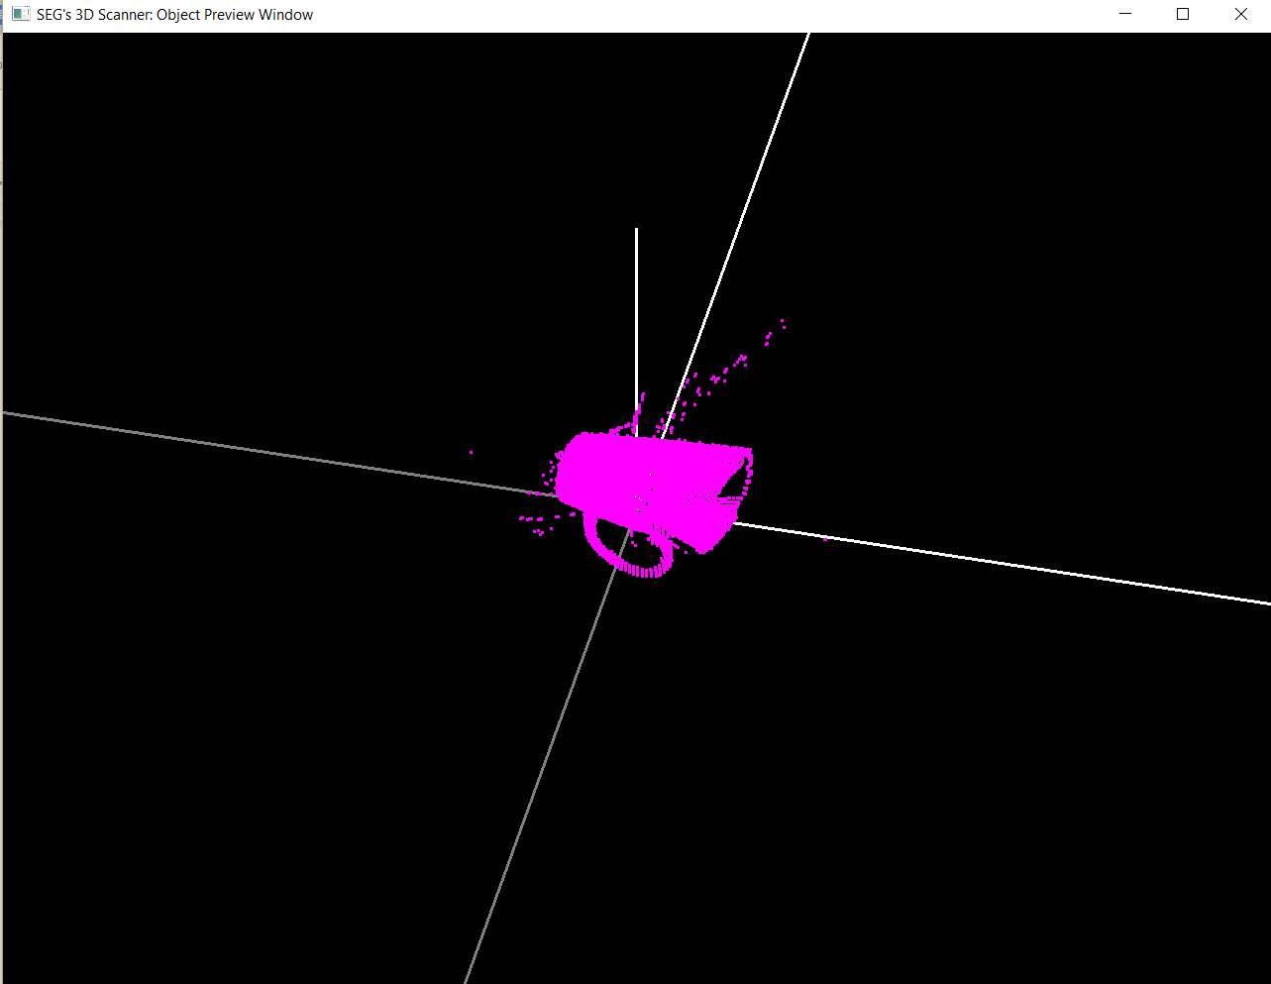

Figure G.3 Image of a Scanned Mug Zoomed Out

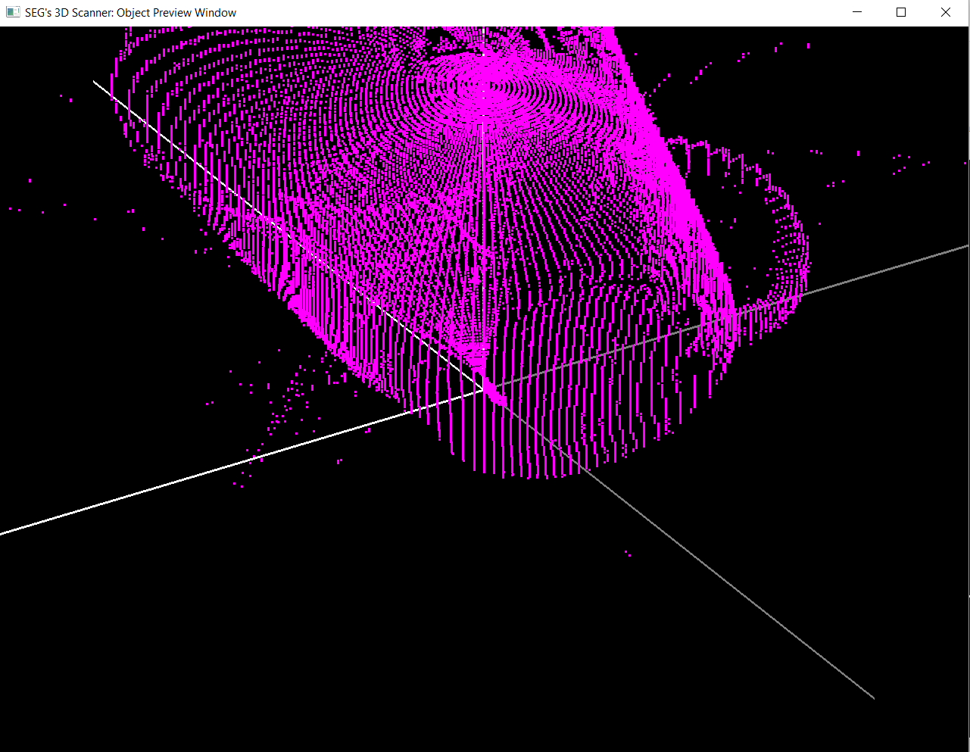

Figure G.4 Image of a Scanned Mug Zoomed In

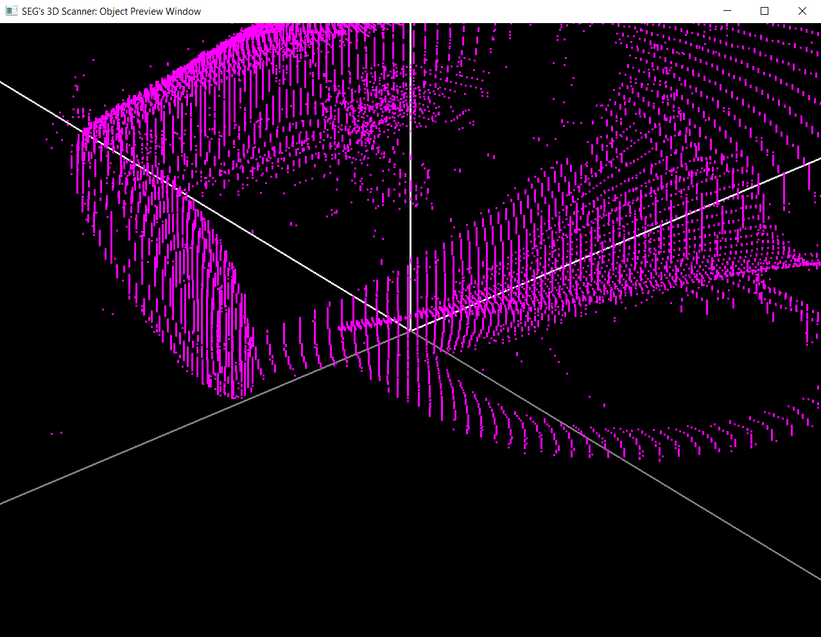

Figure G.5 Image of a Scanned Mug Zoomed In (2)

**Appendix H - 3D Graphics Display of Surfaces of Objects** (author: Emily Miao)

A software is able to mesh the points into surfaces and display the objects in various modes.

The control window is shown in figure H.1. Users are able to rotate the object, move the object, and display the object in the various styles listed below:

1. Points mode - view the object as the 3D points that has been scanned and computed.

2. Outlines mode - view the object by showing only the edges of the object.

3. Solid mode - view the object as a solid that’s filled in with a color.

4. Wireframe mode - view the object with the computed meshed surfaces.

5. Solid with outlines mode - view the object as a solid that’s filled in with color, and outlined with the computed meshed surfaces.

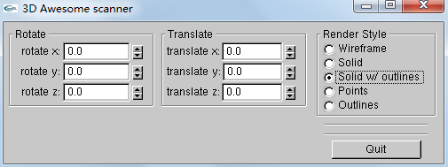

Figure H.1 Graphics Display Control Console

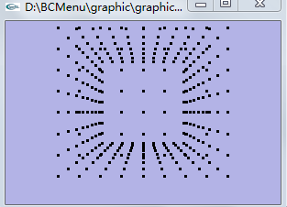

Figure H.2 Points Display

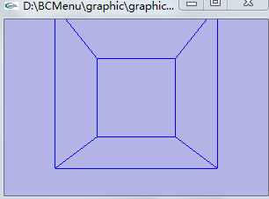

Figure H.3 Outlines Display

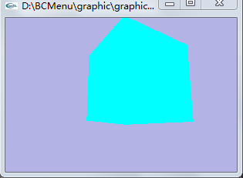

Figure H.4 Polygon Display

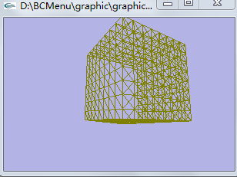

Figure H.5 Mesh Surface Display

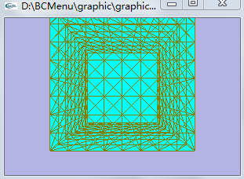

Figure H.6 Color Filling Mesh Surfaces Display